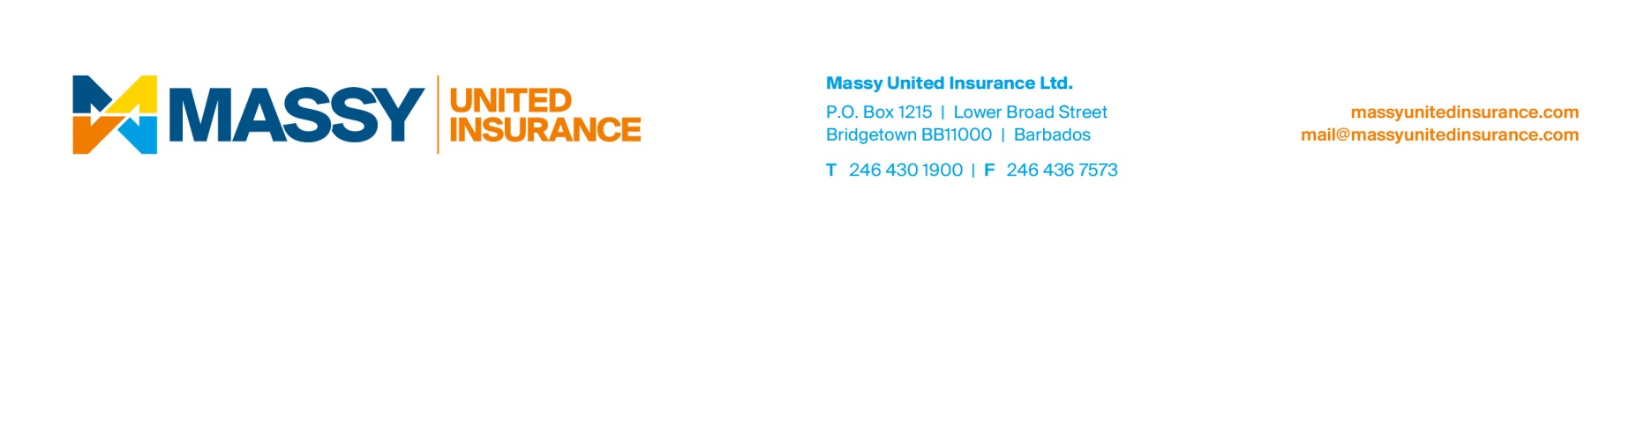
Attention: News Editors
FOR IMMEDIATE RELEASE
January 12, 2015
We’re Changing to Serve You Better
We are pleased to announce that the name of our business has changed from United Insurance Company Limited to Massy United Insurance Ltd. This change comes as part of a regional rebranding exercise conducted by our parent company, the Massy Group formerly Neal & Massy.

This rebrand is a part of the group’s strategy to optimize growth across its 60 businesses, with a new vision to be a “Force for Good” as the most responsible and profitable investment holding/management company in the Caribbean Basin.

Mr. Howard Hall, chief executive officer of Massy United Insurance Ltd. assures stakeholders that this change will not affect current policy coverage with the company.

He added, “As always you can trust us to protect your home, vehicle, business and other prized possessions. We continue to boast an A.M. Best International rating of A- Excellent for the tenth consecutive year which is an indication of the company’s financial strength and continued stability.”

Massy United Insurance will continue to provide the same excellent service on which our reputation in the industry was built. United Insurance Agents (Saint Lucia) Ltd. has been representing our interests and will continue to serve our policy holders in St. Lucia.

About Massy United Insurance Ltd.
Massy United insurance Ltd. is one of the leading general insurance companies in the English and Dutch-speaking Caribbean. It is headquartered in Barbados, registered in 14 countries and serves its clients via a network of Agents and Sub-Agents across the Caribbean. Known for its financial strength, Massy United Insurance offers its clients a full range of market-leading private and business insurance solutions.

Massy United Insurance is a member of the Massy Group.

For more information about Massy United Insurance Ltd., visit www.massyunitedinsurance.com

Should you have any questions please contact,
Tricia Yearwood
Marketing Officer
Massy United Insurance
Barbados
T: 246.430.1900 | E tricia.yearwood@massygroup.com

